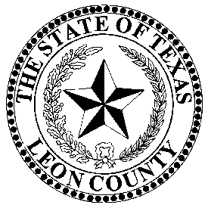 | LEON COUNTY TAX ASSESSOR/COLLECTOR
 | VICTORIA WILLIS
P.O. Box 37, 155 N Cass Street, Centerville, Texas 75833 903/536-2543 903/536-2431-FAX
Victoria.willis@co.leon.tx.us, leoncountytax.org,

INSTRUCTIONS FOR WAIVER OF PENALTY AND INTEREST PER SECTION
33.011 OF THE TEXAS PROPERTY TAX CODE

ONLY FOR CITY ACCOUNTS THAT ARE IN LEON COUNTY

- The account must be paid in full (includes penalty, interest and collection fees), within 21 days of knowing of the delinquency before a request for waiver of penalty, interest and collection fees would be considered by City Council.

- The taxpayer must issue a written request for waiver of penalty, interest and collection fees to:

Mayor, Jerrod Jones
City of Buffalo
P.O. Box 219
Buffalo, Texas 75831

Mayor, Troy Noey
City of Normangee
P.O. Box 37
Normangee, Texas 77871

Mayor, John Sitton
City of Jewett
P.O. Box 189
Jewett, Texas 75846

Mayor, Jacquelyn Morrow
City of Oakwood
P.O. Box 96
Oakwood, Texas 75855

Mayor, Stynette Clary
City of Marquez
P.O. Box 85
Marquez, Texas 77865

Mayor, Noal Ray Goolsby
City of Centerville
P.O. Box 279
Centerville, Texas 75833

- The request must include: Account number, legal description, year(s) in question, plus the taxpayer’s current mailing address and telephone number.

It is up to the taxpayer to provide substantial proof that an error was made by the Tax Office, the Central Appraisal District or any other provisions in Section 33.011 of the Texas Property Tax Code to allow the waiver of penalty, interest or collection fees.

- The City Secretary’s office will notify the requesting taxpayer of the date the request will be on City Council’s agenda.

***NOTE: The Leon County Tax Office records are open to the public. Our office is open from 8:00 AM to 4:30 PM Monday thru Friday. For extensive research, please call the Tax Office. The phone number is (903) 536-2543.

